**The topic .**

**Lecture**

What is docker?

Why docker?

Docker Way Vs Traditional Way?

Docker System Overview

What are Docker Image ,Dockerfile , Container ?

**Workshop**

1. Installation
2. Register Docker Hub (Registry)
3. Create Dockerfile
   1. FROM
   2. COPY
   3. ENTRYPOINT
4. Build Dockerfile
5. Push Docker Image to Docker Hub
6. Run Docker with manual command
   1. Expose Port
   2. Volume
   3. Network
7. Run Docker with docker-compose
8. Example NodeJs App
9. Example Golang APP

**Lecture**

1. **What is docker?**

Docker is a set of platform as a service (PaaS) products that uses **OS-level virtualization** to deliver **software in packages called containers**.[6] **Containers** are **isolated** from one another and bundle their own software, libraries and configuration files; they can **communicate** with each other through well-defined channels.[7] All containers are run by a **single operating-system kernel** and are thus more lightweight than virtual machines.[8]

<https://www.softwaretestinghelp.com/container-software/>

1. **What are problems that docker solved?**

* Environment Problem (Work on my computer but not on production!!)
* Scaling Problem (Work with Container Orchestration Such K8S, Swarm)
* CI/CD

1. **Docker Way Vs Traditional Way?**

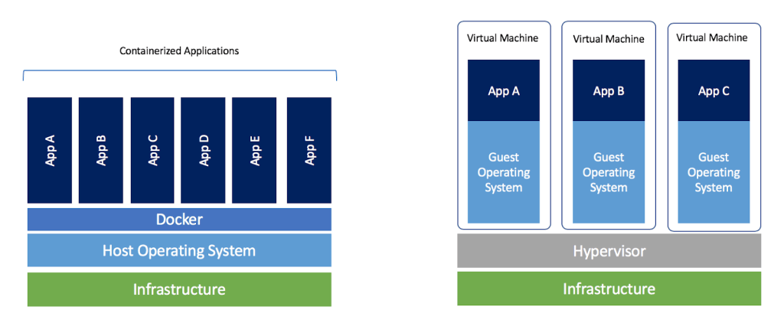

* Fast Deployment
* Use resources less than traditional ways.

1. **Docker System Overview**

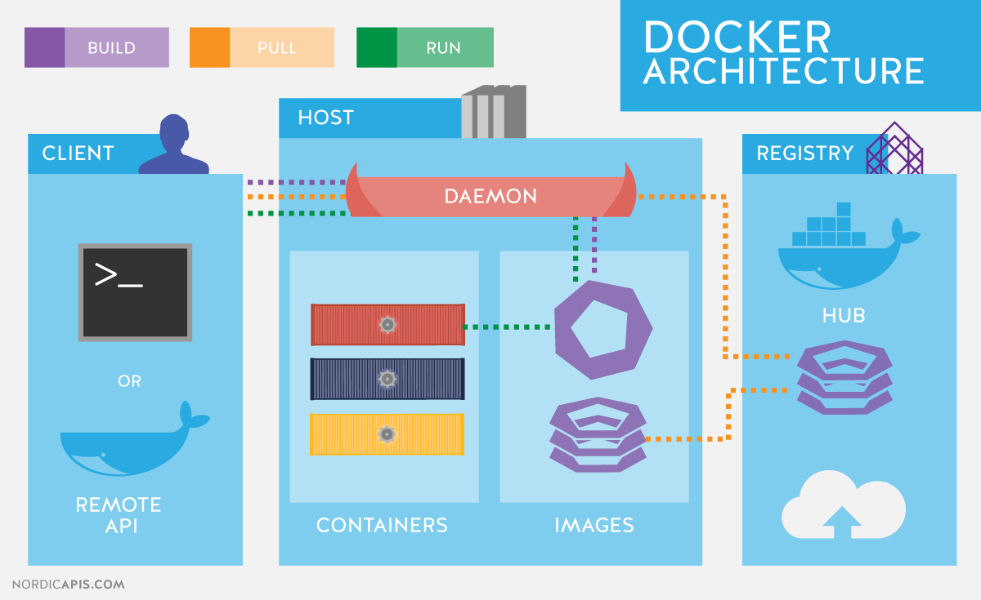

1. **What are Docker Image ,Dockerfile , Container ?**

**Dockerfile(Build)-> Image(Run)->Container**

**การสร้าง Build Dockerfile**

**โจทย์**

* **Ubuntu 19.04**
* **Wordpress App**
* **MySQL**

**Note**

* **ทุก Dockerfile ต้องมี OS เสมอ**

**myos/Dockerfile**

|  |
| --- |
| **FROM ubuntu:19.04**  **RUN echo "I'm Art"**  **RUN echo "I'm Software Developer at IFRA"** |

**Build myos**

|  |
| --- |
| **docker build -t nattaponra/myos:1.0 .** |

**Show my image in host**

|  |
| --- |
| **docker images** |

**Push myos into Docker Hub**

|  |
| --- |
| **docker push nattaponra/myos:1.0** |

**ดู image ที่ push ขึ้นไปได้ที่**

[**https://hub.docker.com/repositories**](https://hub.docker.com/repositories)

**Art: nattaponra/myos:1.0**

**L: siravit/myos:1.0**

**C: zsevens/myos:1.0**

**Tum:panupong302/myos:1.0**

**รัน container ด้วยคำสั่ง**

|  |
| --- |
| **docker run -it nattaponra/myos:1.0** |

**wordpress/Dockerfile**

|  |
| --- |
| **FROM zsevens/myos:1.0**  **RUN apt update**  **RUN apt install -y curl**  **RUN apt install -y nginx**  **COPY html /var/www/html**  **RUN rm -rf /etc/nginx/sites-enabled/default**  **COPY nginx/default.conf /etc/nginx/sites-enabled/**  **RUN apt install -y php-fpm**  **RUN apt install -y php-mysql php-gd**  **RUN chown -R www-data:www-data /var/www/html/**  **CMD service php7.2-fpm start && nginx -g "daemon off;"** |

**Build**

|  |
| --- |
| **docker build -t nattaponra/mywordpress:1.0 .** |

**Run APP**

**docker run -p 80:80 -it nattaponra/mywordpress:1.0**

**Default config /etc/nginx/sites-enabled**

**Ref (Install Nginx):** [**https://www.digitalocean.com/community/tutorials/how-to-install-nginx-on-ubuntu-18-04-quickstart**](https://www.digitalocean.com/community/tutorials/how-to-install-nginx-on-ubuntu-18-04-quickstart)

**แก ้ config Nginx** [**https://linuxize.com/post/how-to-install-php-on-ubuntu-18-04/**](https://linuxize.com/post/how-to-install-php-on-ubuntu-18-04/)

**Ref:** [**https://docs.docker.com/get-started/part2/**](https://docs.docker.com/get-started/part2/)

**Image**